
Dear Mark,

It was a pleasure meeting with you and discussing the elevation of your Brand "Hill Billy" and taking your company to the next level.
Also watching how you light up when discussing reigniting your passion project "Urban Influences".
I am inspired to assist you in manifesting your ideas into actual working enterprises that employ others and enrich the community.
I look forward to us working together, as we build your brand and manifest your dreams into actual reality here.
Be Free,
Kimberly



4

Hill Billy & Urban Influences
Weekly Business Consulting Journal

April 2012 VOL # 1ISSUE #1

Kismet Coach, LLC


We will work on the business proposal together, knocking out each chapter every 2 weeks.

We will be done in time to get both companies fully ready to start requesting funding by the end of Level 1 Start Up.
Please Click Here to download a copy the Consultant Agreement.
Please Click Here to download a copy of SBA Business Plan Template.
_______________________________

BUSINESS PLAN TEMPLATE
WEEKLY SCHEDULE
Week1& 2: Chapter 3- Business Description & Vision
Week 3& 4: Chapter 4- Definition of Market
Week 5& 6: Chapter 5- Description of Products & Services
Week 7&8: Chapter- Organization & Management
Week 9&10: Chapter 7- Marketing & Sales
Week 11& 12: Chapter 8 - Financial Management
Week 13 & 14: Chapter 1 & 9 Appendix & Executive
NON PROFIT SHORT PROPOSAL
Week 1: Non Profit Purpose Statement
Week 2: 1-2 Page Description of Program

.

DOCUMENTS
Consultant Agreement
Business Plan Template


Kimberly Manning MSW

Level 1 Start Up

- Begin May 3, 2012 and Ends August 3, 2012.
- 2 Face to Face A Month Consultation Sessions
- 2 Consultation Calls A Month
- Emails Contact and 15 minute Calls in between Sessions
- Weekly Personalized Business Newsletter



SCHEDULE

Level 1 Start Up

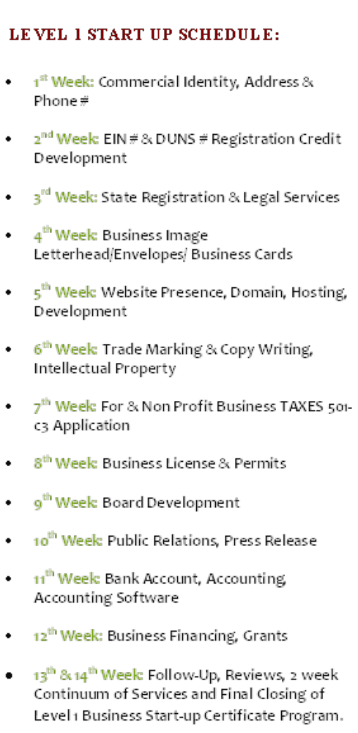

Be Free To Live Your Destiny
April, 2012 VOL #1 ISSUE #1




HEADLINE
SUBHEAD. SUBHEAD.
SUBHEAD. SUBHEAD.

Continue newsletter text here. Continue newsletter text here. Continue newsletter text here. Continue newsletter text here. Continue newsletter text here. Continue newsletter text here. Continue newsletter text here. Continue newsletter text here. Continue newsletter text here. Continue newsletter text here. Continue newsletter text here.
Continue newsletter text here. Continue newsletter text here. Continue newsletter text here. Continue newsletter text here. Continue newsletter text here. Continue newsletter text here.
Continue newsletter text here. Continue newsletter text here. Continue newsletter text here. Continue newsletter text here. Continue newsletter text here. Continue newsletter text here. Continue newsletter text here.
Continue newsletter text here. Continue newsletter text here. Continue newsletter text here. Continue newsletter text here. Continue newsletter text here. Continue newsletter text here. Continue newsletter text here. Continue newsletter text here.

Delete box or place a caption here.
Delete box or place a cption here.
MONTH, YEAR VOL # ISSUE #




BUSINESS WORK
Review Consulting Agreement and Business Plan Template on Document Page
Please email me any desired additions, revisions and your payment schedule choice from Part #3 on Consulting Agreement by this Monday April 30th, (My office sends out invoices every Monday).

Kimberly Manning, MSW is the CEO of Kismet Coach, LLC International Life Coach and Business Consultant Firm.
Kimberly Manning is a Master Spiritual Life Coach, Business Consultant and Entrepreneur She Owns 5 For Profit Businesses and 1 Non-Profit Organization.
Kim’s Mission is to help others find wealth and success through business ownership and balanced living.

April, 2012 VOL #1 ISSUE #1

www.kismetcoach.com
855-880-1071



